INSTRUCTIONS TO AUTHORIZE A PRACTITIONER TO SHARE RECORDS

Step 1 – Login to your patient portal and click on the Questionnaires button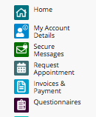

Step 2: Please select the appropriate questionnaire to complete underneath the Records Release/Coordination of Care Section. If you want ongoing communication please select the form that includes coordination of care. Complete and sign the release form electronically and the practitioner will be added to your care team to receive records:
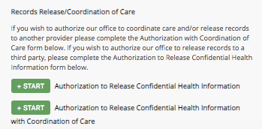
STEP 3: : Please send us a message via your patient portal to indicate what records to send to this practitioner:

